Types of inheritance in java

On the basis of class, there can be three types of inheritance in java: single, multilevel and hierarchical.

In java programming, multiple and hybrid inheritance is supported through interface only. We will learn about interfaces later.

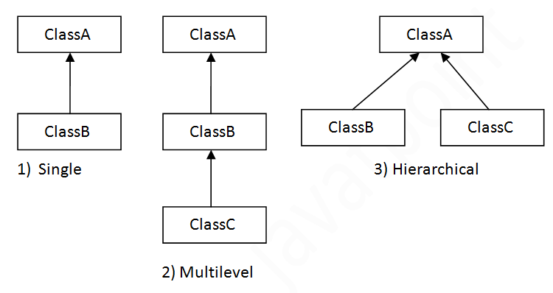

**Note: Multiple inheritance is not supported in java through class.**

When a class extends multiple classes i.e. known as multiple inheritance. For Example:

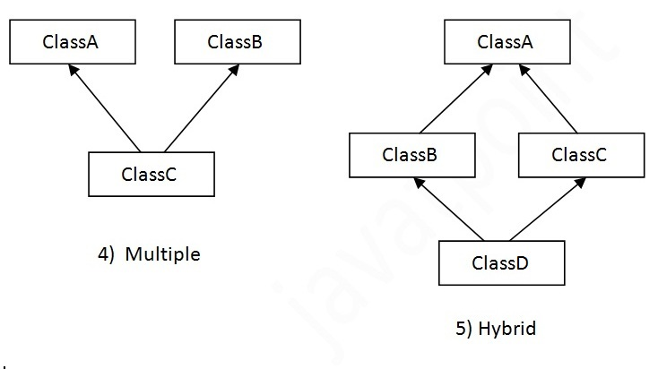

Single Inheritance Example

*File: TestInheritance.java*

1. **class** Animal{
2. **void** eat(){System.out.println("eating...");}
3. }
4. **class** Dog **extends** Animal{
5. **void** bark(){System.out.println("barking...");}
6. }
7. **class** TestInheritance{
8. **public** **static** **void** main(String args[]){
9. Dog d=**new** Dog();
10. d.bark();
11. d.eat();
12. }}

Output:

barking...

eating...

Multilevel Inheritance Example

*File: TestInheritance2.java*

1. **class** Animal{
2. **void** eat(){System.out.println("eating...");}
3. }
4. **class** Dog **extends** Animal{
5. **void** bark(){System.out.println("barking...");}
6. }
7. **class** BabyDog **extends** Dog{
8. **void** weep(){System.out.println("weeping...");}
9. }
10. **class** TestInheritance2{
11. **public** **static** **void** main(String args[]){
12. BabyDog d=**new** BabyDog();
13. d.weep();
14. d.bark();
15. d.eat();
16. }}

Output:

weeping...

barking...

eating...

Hierarchical Inheritance Example

*File: TestInheritance3.java*

1. **class** Animal{
2. **void** eat(){System.out.println("eating...");}
3. }
4. **class** Dog **extends** Animal{
5. **void** bark(){System.out.println("barking...");}
6. }
7. **class** Cat **extends** Animal{
8. **void** meow(){System.out.println("meowing...");}
9. }
10. **class** TestInheritance3{
11. **public** **static** **void** main(String args[]){
12. Cat c=**new** Cat();
13. c.meow();
14. c.eat();
15. //c.bark();//C.T.Error
16. }}

Output:

meowing...

eating...

Q) Why multiple inheritance is not supported in java?

To reduce the complexity and simplify the language, multiple inheritance is not supported in java.

Consider a scenario where A, B and C are three classes. The C class inherits A and B classes. If A and B classes have same method and you call it from child class object, there will be ambiguity to call method of A or B class.

Since compile time errors are better than runtime errors, java renders compile time error if you inherit 2 classes. So whether you have same method or different, there will be compile time error now.

1. **class** A{
2. **void** msg(){System.out.println("Hello");}
3. }
4. **class** B{
5. **void** msg(){System.out.println("Welcome");}
6. }
7. **class** C **extends** A,B{//suppose if it were
9. Public Static **void** main(String args[]){
10. C obj=**new** C();
11. obj.msg();//Now which msg() method would be invoked?
12. }
13. }

[**Test it Now**](http://www.javatpoint.com/opr/test.jsp?filename=C)

Compile Time Error

class Calculation {

int z;

public void addition(int x, int y) {

z = x + y;

System.out.println("The sum of the given numbers:"+z);

}

public void Subtraction(int x, int y) {

z = x - y;

System.out.println("The difference between the given numbers:"+z);

}

}

public class My_Calculation extends Calculation {

public void multiplication(int x, int y) {

z = x * y;

System.out.println("The product of the given numbers:"+z);

}

public static void main(String args[]) {

int a = 20, b = 10;

My_Calculation demo = new My_Calculation();

demo.addition(a, b);

demo.Subtraction(a, b);

demo.multiplication(a, b);

}

}